Use Case Realisation Report (Analysis) - Search Project Member
FOR
Volunteer Management System
(VMS)

CLIENT
PROJECT | Volunteer Management System(VMS) - VMS/T-1.4.1/1
TITLE | Use Case Realisation Report (Analysis) - Search Project Member
VERSION | 0.3a0.2a
DATE | 14-Aug-2011
 | ORIGINATOR
 | Name / Signature | Team 8S
 | APPROVAL
 | Name / Signature | Phung Kim Cuong, Dio
Institute of Systems Science |  | Document Reference
25 Heng Mui Keng Terrace  Singapore 119615 |  | VMS/T-1.4.1/1

 | Acceptance
 | Customer Signature |  | Customer Signature
 | Name & Designation |  | Name & Designation
 | Date & Company Stamp |  | Date & Company Stamp

Revision History

Date | Version | Description | Author
12-Jun-2011 | 0.1a | Creation | Team 8S
14-Aug-2011 | 0.2a | Update | Team 8S
 |  | Refer to amendment history

Table of Contents

1. Brief Description 4
2. Flow of Events 4
2.1 Search Project Member: 4
2.2 Exceptions 5
3. Interaction Diagrams 6
3.1 Collaboration Diagram for Search Project Member 6
4. Participating Objects 6
4.1 User (entity) 6
4.2 User (actor) 6
4.3 Project 6
4.4 Membership 6
4.5 MembershipListingScreen 6
4.6 HomeScreen 7
4.7 MainController 7
4.8 MembershipController 7
4.9 UserController 7
4.10 ProjectController 7
Class Diagram 7
5. 7
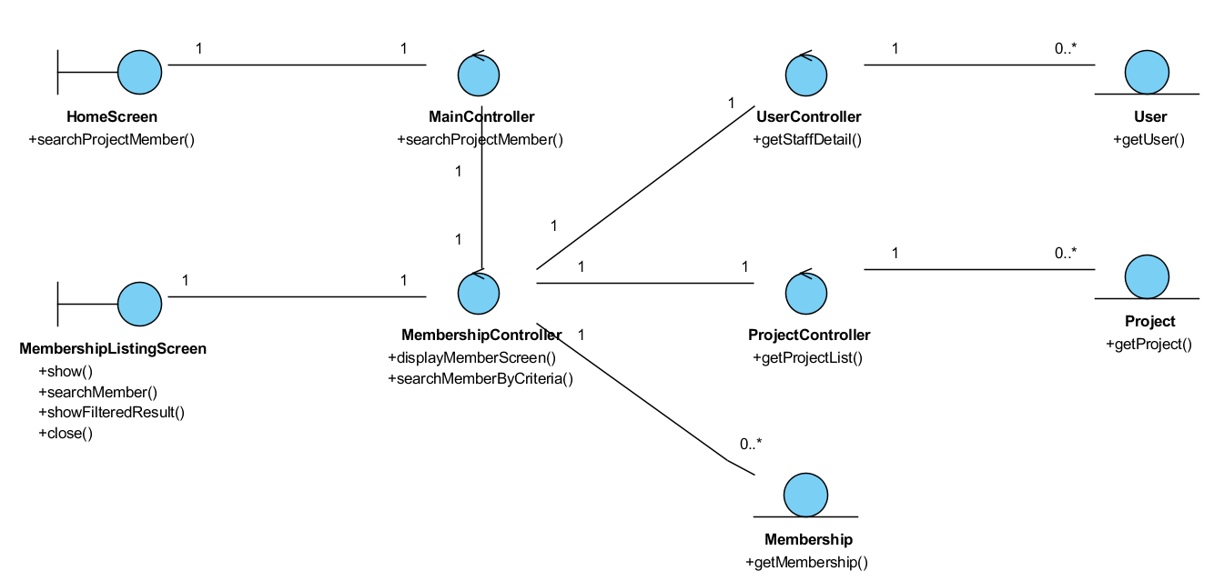 7
6. Derived Requirements 7
ANNEX D Amendment History 8

Use Case Realisation Report (Analysis) - Search Project Member

Brief Description
The use case enables any user of the system (can be a volunteer or internal staff) to view the member list of a project. Information display is based on the roles of the user.

Flow of Events
The standard flow of events for this use case and any exceptions are described in the following subsections. See section 3.1 for an overview of the participating Actors and Domain Objects.

Standard Flow
Precondition: User has logged in the system
The workflow is as below:

Search Project Member:
- The use case starts when the User selects the menu option from the HomeScreen. The HomeScreen.searchProjectMember() operation is triggered.
- The HomeScreen searchProjectMember() operation delegates to the MainController searchProjectMember() operations, which in turn trigger the displaySearchMemberScreen() operation of the MembershipController.
- The MembershipController will then using the UserController.getUserProfile() method to get the current logged in user via the User.getUser().
- Then the MembershipController will trigger ProjectController.getProjectList() to get the list of all projects available for viewing members
- Based on the user profile and the project list, the MembershipController will trigger Membership.getMembership() to return the list of member for each project.
- Then the MembershipController will display the list via MembershipListingScreen show() method.
- The user then key in the search criteria and click Search, which trigger MembershipListingScreen.searchMember() method.
- Using the parameter in searchMember(), the MembershipListingScreen will call the searchMemberByCriteria() method of MembershipController, which then will filter the list and display on the screen via showFilteredResult() method
- User now can see the list of the project member on the MembershipListingScreen, the use case terminates when user click Close button which trigger close() method of the screen.

Exceptions
The following exceptions were identified:
- No result return. If the MembershipController.showFilteredResult() operation does not return any record , the MembershipListingScreen still show with an empty listing for that project.

Interaction Diagrams

Collaboration Diagram for Search Project Member
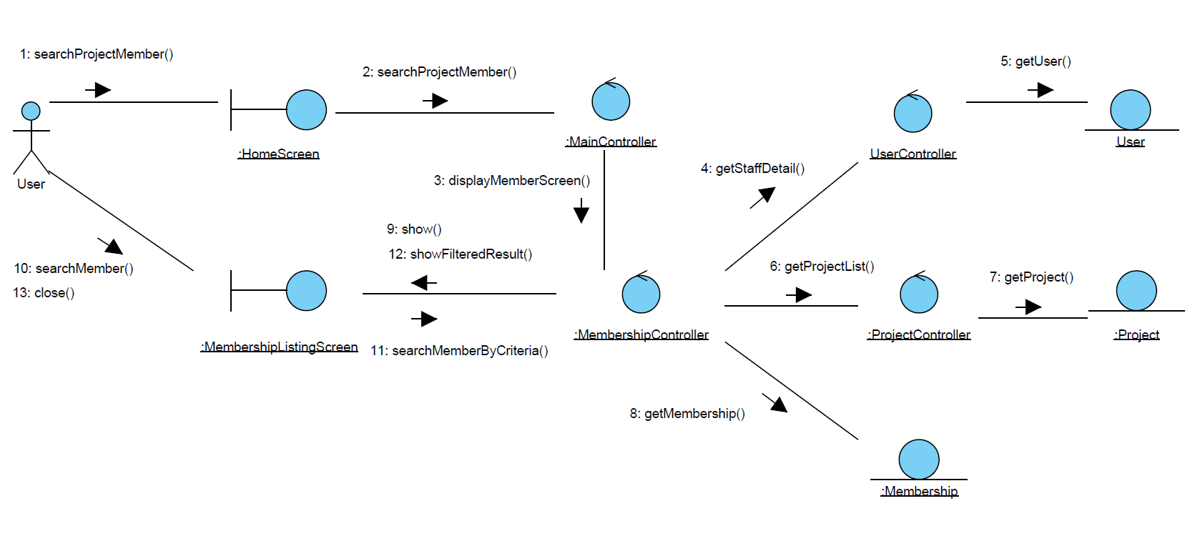
Figure 1 – Collaboration Diagram for Search Project Member

Participating Objects

User (entity)
This entity object represents a registered user of the system, and stores the detailed profile of that user. The primary attribute that it holds is the userID.

User (actor)
This is a user actor type which represents anyone who interacts with the system.

Project
This entity object stores the details concerning a project of the volunteer organisation. The primary attribute that it holds is the projectID.

Membership
This entity object stores the details concerning the membership of an volunteer in a project inside the volunteer organisation. The primary attribute that it holds is the membershipID.

MembershipListingScreen
This boundary object is used for displaying a collection of project members. User actor uses this object.

HomeScreen
This boundary object is used for redirecting and displaying of home screen details and menu. All the user actors use this object.

MainController
This control object co-ordinates the menu selection and dispatches of requests of the volunteer management system. It delegates the user requests to the specific use case control objects for carrying out the use cases.

MembershipController
This control object co-ordinates the creation, update, viewing and searching project record in the volunteer management system. It receives requests from the boundary objects allocated for the specific purposes, along with all the necessary details required for the execution of these requests.

UserController
This controller object co-ordinate the operations on a user profile (searching, viewing, creating of user profile). In this use case it will be in charge of getting the user profile details.

ProjectController
This controller object co-ordinate the operations on a project entity (searching, viewing, creating, updating). In this use case it will be in charge of getting the project entity details.

Class Diagram

Figure 2 Class diagram

Derived Requirements
The Staff office PC (client system), keyboard and mouse will be used to process the project details and view all the system responses.

ANNEX D Amendment History

This is a record of all amendments made to the Document.
Version | Chapter / Section | Page No | Notes of Amendments or Changes

